Genetically Improving the Pig from 1960-2016 by John Millard

Thank you to Angelos Kachrimanidis and all at Vethellas for inviting me to you seminar and thank you for all your good hospitality, business and comradeship over the past 24 years.

First and foremost, I am a farmer who has found I have the ability to improve breeding pigs, I am not a professor. I have exported breeding pigs to 58 countries to improve their pigs genetics. In this presentation I will be discussing the changes we have seen in the pig over the last 56 years and the strategies I have used in my own breeding programmes by combining the art and science of genetic improvement. It has been our goal to produce a pig that is economically improved, but is also easy to manage across the world. I will look at the results I have achieved and the success reported by my customers. If I had another life I would love to breed racehorses and correct the racehorse breeding policies.

The improvements in the pig have been dramatic, in 2010 1kg of feed produces 2.7 times more lean meat than it did in 1960. Pigs grow faster and feed conversion ratio (FCR) has improved from 3.2 to 2.3. We have seen changes in the carcass composition with the lean meat percentage improving from 48% to 63%.

These genetic improvements have been driven by the goal of producing more lean meat at a lower cost and increasing financial rewards:
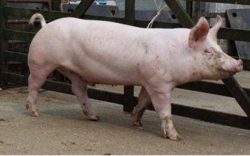
  - Increase Lean Meat Percentage
  - Improve Growth Rate
  - Improve Litter Numbers Born
  - Improve Litter Numbers Reared (piglets/sow/year)
  - Improve Longevity of the Sow

The Pig Improvement Revolution
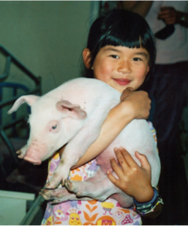
We have seen the pig improvement revolution spread across the world and this has tied into the pattern of international export of our pigs.

1950 UK, Denmark, France, Holland, Norway, Sweden & Finland
1965 Eastern Europe, Hungary, Poland, Czech Republic, Greece
1975 Asia, Thailand, Phillipines, Korea, Canada, USA, Russia
1985 Vietnam
2000 China
2015 Africa

Note that 50% of the world’s pigs are in China and in 2014 only 18% of their pigs were a modern breed. Our modern pig only eats 60% of the food that the old fashioned Chinese pig eats to reach bacon weight (100kg live weight). Therefore, if all the pigs in China were modern there would be a 12% surplus of soya bean meal in the world and a 12% surplus of cereals.

UK Central Testing Scheme
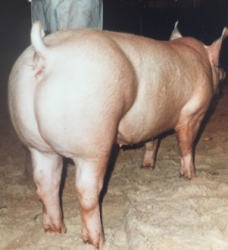
The UK has a history of exporting breeding stock to improve the world’s livestock, including, cattle, pigs, sheep and racehorses. A scheme to improve the national herd by The Pig Industry Development Authority (later the Meat and Livestock Commission) ran Central Testing Stations to test pigs on performance and carcass composition. About 300 pedigree herds were involved in the testing scheme and in 1963 my herd was one of the top tested herds. Best performing boars could then be used by AI stations, other breeders and exported abroad for breed improvement. This selection along with the performance data gathered, facilitated rapid improvement in carcass quality and growth rate. Later, on-farm testing and ultrasonic back fat testing took over from Central Testing Stations mainly because of Biosecurity.

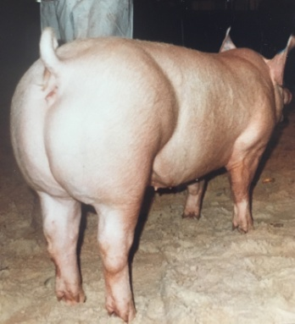
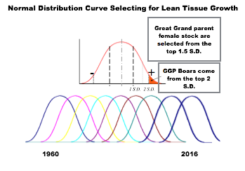
In our herd we also changed the shape of the pig to improve ham shape, particularly in the case of the Large White, we increased the ham and loin and reduced the shoulder and belly.

Dangers of Single and Dual Trait Selection
Whilst all genetic improvement was focused on rapidly improving the lean tissue growth rate, many pig breeders did not also select for some fundamental traits of the pig. We have seen the dangers of single and dual trait selection across the livestock breeding industry. We can look at the Canadian Holstein as an example, heavily genetically selected for milk yield and butterfat but not selected for longevity or conformation and as a result the highest yielding cows are unable to average two lactations.

Keeping the Pig Functional and Balanced
We need to breed pigs that will improve lean tissue growth rate but most importantly ensure we are breeding a pig that will be functional, balanced and easy to manage. I will describe the other areas I have focused on in my breeding programmes to ensure we breed an animal for the future that is easy to manage.

- Teats - Some major breeding companies have not improved and selected for the number and shape of teats. It is no use having 18 pigs born if your sows only have 12 nipples. Shape and spacing is so important, the piglet must be able to get the nipple into its mouth easily and suckle the milk. Nucleus herds should cull any gilts or boars without correctly shaped teats and numbers of teats.

- Legs - Our modern pigs need strong legs with thick bones and strong even feet to carry the extra muscle of the modern pigs. I select for strong pasterns that have some spring in them especially as most of today’s pigs live on concrete. Pigs should be selected for good locomotion with a leg on each corner for good stability.

- Reduce Abnormalities - Nucleus herds should record abnormalities, hernias and blind anus and reduce these abnormalities by culling sows that produce hernias, and culling boars that produce more than 1 in 500. Some of our Duroc Boars were placed on an AI stud in Denmark, our boars' progeny reduced the percentage of hernias in their progeny by over 80%.

- Fertility - I have met some farmers in Europe who only get 75% of gilts pregnant at the first mating, that costs a lot of money. I would advise to only keep Great Grand Parent (GGP) sows that become pregnant easily on the first mating, and by doing this we have improved the conception rate on first mating on F1 gilts from 85% to 99% during the last 50 years.

- Stress - We still test all the young boars for Porcine Stress Syndrome, and only keep the negative boars, to ensure we do not have stress in our herd. With this selection, we have lost a little bit of extreme ham shape, but we do NOT have any problems with pigs dropping dead during transport.

- Selection Rate - The selection rate on our F1 gilts has gone up from 28% to 85% over the last 50 years because we have improved the teat shape and numbers and corrected the feet shape. We used to cull 40% of our gilts for poor teats alone, now due to improvements, it is only about 5% plus we have improved the leg and feet so much over 50 years.

- Embryo Survival - During my lifetime, numbers born alive in the Large White Breed have increased by three piglets. Reducing embryo death is the key to increasing numbers born. In 1986 - 1988 we were transferring embryos from High Genetics to High Health Sows to upgrade the genetics in a high health herd. Five days after ovulation, we had an average of 29 embryos fertilised but only 12 pigs born alive. From this data, we concluded that fertilisation was not a problem, but that embryo survival was limiting numbers born. Nine days after fertilisation the embryos embed into the uterus and stretch out to 150mm long, if there is not a clear space the embryos just drop off, creating embryo loss. It is also noted that longer sows have longer uteruses and therefore more piglets born. We had observed that for many years, before we knew the scientific reason why. The conclusion is that with correct management and diet, fertilisation is not a problem affecting number born, instead embryo survival is the key. Our customers with very small herds; 2 - 10 sows get incredibly high numbers born. I met a customer this summer who has Large White sows averaging over 20 born after the first litter! I put this down to these sows not getting knocked about by other sows, and therefore, they lose very few embryos in pregnancy.

The result of good teat shape, high teat numbers, strong legs, good fertility, reduced stress and higher selection rates makes the pigs EASIER TO MANAGE.

Customer Success
Over the years my exported breeding stock has improved herds around the world. Here are a few success stories reported by my customers.

- Holland - Ren Van As says ‘500 weaner pigs from my pigs 495 will grow quickly to slaughter weight, and no other company’s pigs grow as quickly’. He says he can buy weaners from one of my big European competitors and only 400 out of 500 grow on to slaughter weight quickly, the other 100 pigs take one to two months longer. The difference in results is mainly because that company only selects for leanness, and numbers born and relies heavily on a Best Linear Unbiased Prediction (BLUP) programme and does not select enough for important other traits.

In my opinion, BLUP is a very good genetic improvement programme and particularly on the maternal side. But if you let BLUP dominate it will eventually lead to inbreeding, an increase in abnormalities, lower conception and poorer conformation. To be a good pig breeder you have to be ruthless and cull out the bad pigs and not keep pigs with faults and maintain heterosis. Along with high numbers born, we need to have to have good strong durable pigs that all grow evenly and quickly from weaning to slaughter weight.

- Thailand - In the nineties we improved the numbers reared in a 3,000 sow herd by 1.6kgs per litter.

- USA - With Shaffers Superior Genetics we improved their carcass quality to be recognised as the best carcass quality in the Mid West.

- Korea - In the nineties our customer Mr Choi broke the growth rate record in the Korean Testing Station.

- China - A group in Chongqing made big improvements to their nucleus herd, shown in the table below.

 | PREVIOUS | JJ GENETICS
ADG (grams) | 720 | 910
FCR | 3.20 | 2.55
Numbers Born Alive | 9.3 | 11.2
- Ghana - Jason Adu Gyamfi found growth rate improved massively. Reducing days to 100kg from 455 days to 138 days.

Utilising Breed Qualities
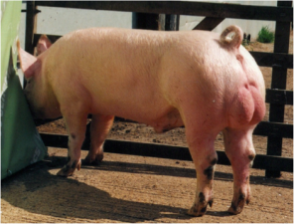
In breeding programmes it is important to utilise the qualities that each breed have to offer.

- Large White or Yorkshire - The faster growing pig that grows lean meat the fastest, it must be 25 - 50% of every commercial programme. Our Large White Breed has been divided into; Dam Lines and Meat Lines

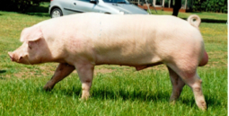
- Landrace Welsh - We mainly use Welsh Landrace and it should be 50% of every female. The advantages of Welsh Landrace in comparison to English Landrace is that she produces more milk, they have stronger legs and feet, extra litters in a lifetime, improved durability and rears more pigs per year.

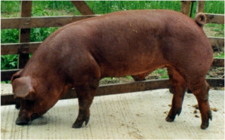
- Duroc - is a very good producer of terminal meat pigs but a poor mother. The qualities of this breed are; fast growing, disease resistant, durable pigs and marbling in the meat to improve taste. There is a higher response for crossbreeding than any other breed. The progeny of our Duroc boars are much less aggressive in the growing stages and most unlikely to fight or tail bite.

Heterosis - Cross Breeding
Our breeding programmes take the heritable traits of the Pedigree pigs and produces a pig that has a combination of these desirable qualities. The result of heterosis is a pig that has more piglets born and reared, faster growth, fewer abnormalities, more disease resistance and stronger legs. What is the importance of using pure pedigree pigs? By using the pure pedigree pigs you will achieve the highest heterosis in comparison to using lines which are made up of various breeds and therefore don't achieve the same level of heterosis. The genetic improvement has to be achieved in the purebred herds, and then cross to produce commercial pigs. The F1 gilt will produce an extra 3.2 pigs per year more than their pedigree parents.

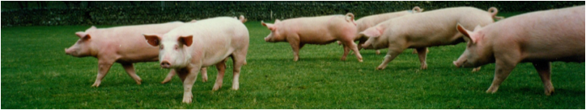

Nutrition
It is very important that whilst all these improvements are being made to the pig, that nutrition is also improved to take advantage of the advancements. The improved pig will require an increase in the density of the pig feed, in particular the amino acids, minerals and vitamins, as well as energy. I believe that milk and fishmeal contain micro ingredients that have not been discovered yet, as lean tissue growth rate responds rapidly to these feeds.

High Health
We obtained our High Health Status using a Segregated Early Weaning (SEW) programme. In a diseased herd the sow has developed immunity to the diseases present and transfers this immunity to the piglets via colostrum and antibodies in her milk. However, when the piglets immunity received from the colostrum is reduced, the piglets become susceptible to diseases in the herd and they get infected by older pigs and by the sow. For example, at 5 days old the piglets become susceptible to Strep Meningitis and at 12 days old, they become susceptible to Mycoplasma Pneumonia.

SEW works because the piglets are weaned before they are 120 hours old while still protected by the antibodies in the mothers colostrum and transferred to a disease free environment over three kilometers away from other pigs. A disease free herd, which is also free of parasites can be developed from these piglets.

Future Developments
In the future I expect that we will continue to see big improvements in daily live weight gain, an increase in pigs reared naturally, and an improvement in taste. For more pigs to be reared naturally, we will need to continue to select for high teat numbers, improve the management of the sow during pregnancy, to minimise loss of embryos and and improve the milking potential of the sow.

There is potential for a big increase to be seen in the daily live weight gain. Daily gain is still increasing 8-10 grams per pig per day. The best pigs are achieving an average of over 1 kilogram daily gain, with the very best individual pigs growing at over 1.5kg a day, from 20 - 120 kilograms with the possibility of this rising to over 2 kgs per day in the future. With these improvements it will be very important to have a good skeleton, strong legs and foot strength to support that fantastic average daily gain. I expect to see continued selection to increase the number of litters a sow has in her lifetime and additionally an improvement in the taste of the meat with more marbling.

