NUTRITION AND ITS EFFECTIVENESS IN PRACTICAL APPLICATIONS IN COMMERCIAL UNITS.
ASSOCIATION OF THE PRODUCTION OF PIG MEAT WITH Renewable energy sources. OPTIMIZATION OF PRODUCTION COST.
The pig industry is a particularly important activity of the agricultural sector of the EU, it constitutes 11% of the European agricultural production (European Commission, 2003).In Greece, the pig industry is considered as a dynamic sectors of the rural economy as it contributes 30% of total meat production although it covers less than 25% of annual requirements in pigmeat. Since the 1960s, with the implementation of governmental funding programs and financial aid, the Greek pig farming began to develop and changed from the domestic form to the industrial. Since 1995, the industry is clearly oriented in enterprise structures and intense concentration of livestock (Batzios, 2001). Despite improvements in recent years, all the pig farms have weaknesses, which certainly are due to the small business development rates of the sector. These weaknesses have resulted in reduced competitiveness of Greek pork in relation to the European. The competitiveness of the Greek pig farming can be improved by increasing productivity and by reducing the total cost of production.
The rearing costs of swine is a function of the total production of pig meat per sow (yield), the average number of sows in production, the average daily gain of pigs and feed conversion (Kitsopanidis, 1999).
Over the last years, pig meat production is declining, while the consumption remains elevated. The highest production was achieved in 1987, with 163.789 tons, according to data from the Ministry of Rural Development. Thereafter a steady decline in Greek production of pork followed, to reach in 2011 to 119.519 tons, while today, according to market players, the domestic production of pork reaches 60-70000 tons, while imports in this meat amounted to 250.000 tons, not including that amount intended for the delicatessen meat industry and meat processing plants. Thus the dependence of our country on imports is growing more and more widening the deficit balance. The amounts of money flowing out of the country, are calculated based on of the above and are over € 0.5 billion a year. If we calculate also the amount which is required by the meat industry, then the total amount needed for pig meat imports reaches one billion €.
The per capita consumption of pork in Greece is about 30 kg per year, while the annual consumption of pork in the European Union is higher and is expected to exceed 45 kg per capita in the near future.
Moreover, growth trends of pork consumption are recorded in Central and Eastern Europe, despite the current economic crisis.
Several studies even argue that in the next 10 years the pork will be the first choice of meat worldwide.
According to the literature, the main factors shaping the overall production cost in a pig farm are the following:
- The feeding cost
- The labor cost and social security contributions
- Expenditure for medicines, vaccines and disinfectant products
- Bank loans and the annual depreciation of assets
- Cost of energy
- Equipment Maintenance Costs
- Miscellaneous - unexpected expenses

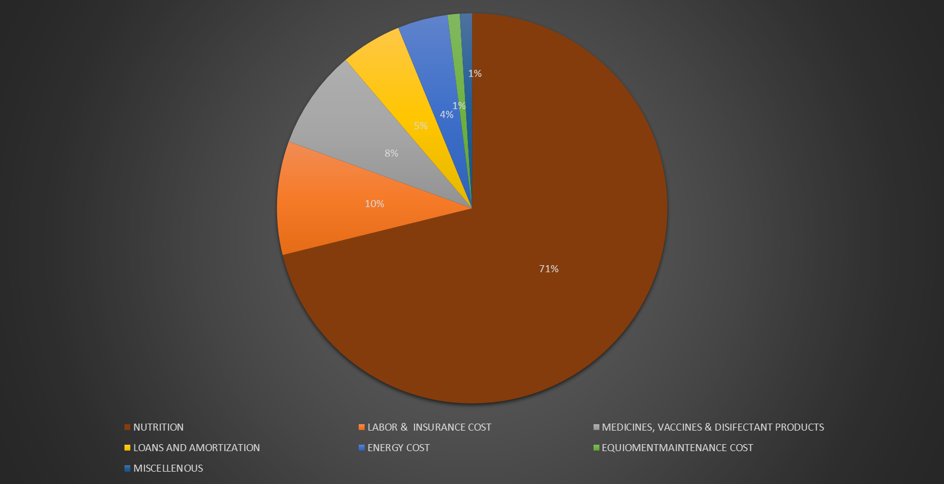
Chart 1. Percentage contribution of cost factors in a pig farm
Nutrition is the biggest factor shaping the production costs by 64 - 72%, depending on the current feed prices (Interpig report 2014).Feed prices have wide variations not only between different countries but even in the same country during the year (AHDB Pork, 2014).
Table 1 Meat production cost for carcasses type 79% in some countries, 2014 (in pounds)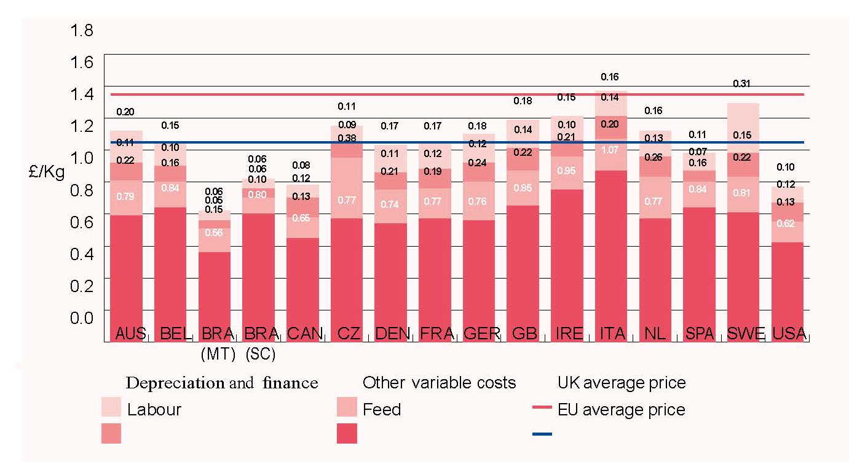

Table 2. Summary of economic meat production factors for 79% carcasses type in certain countries, 2014 (in pounds)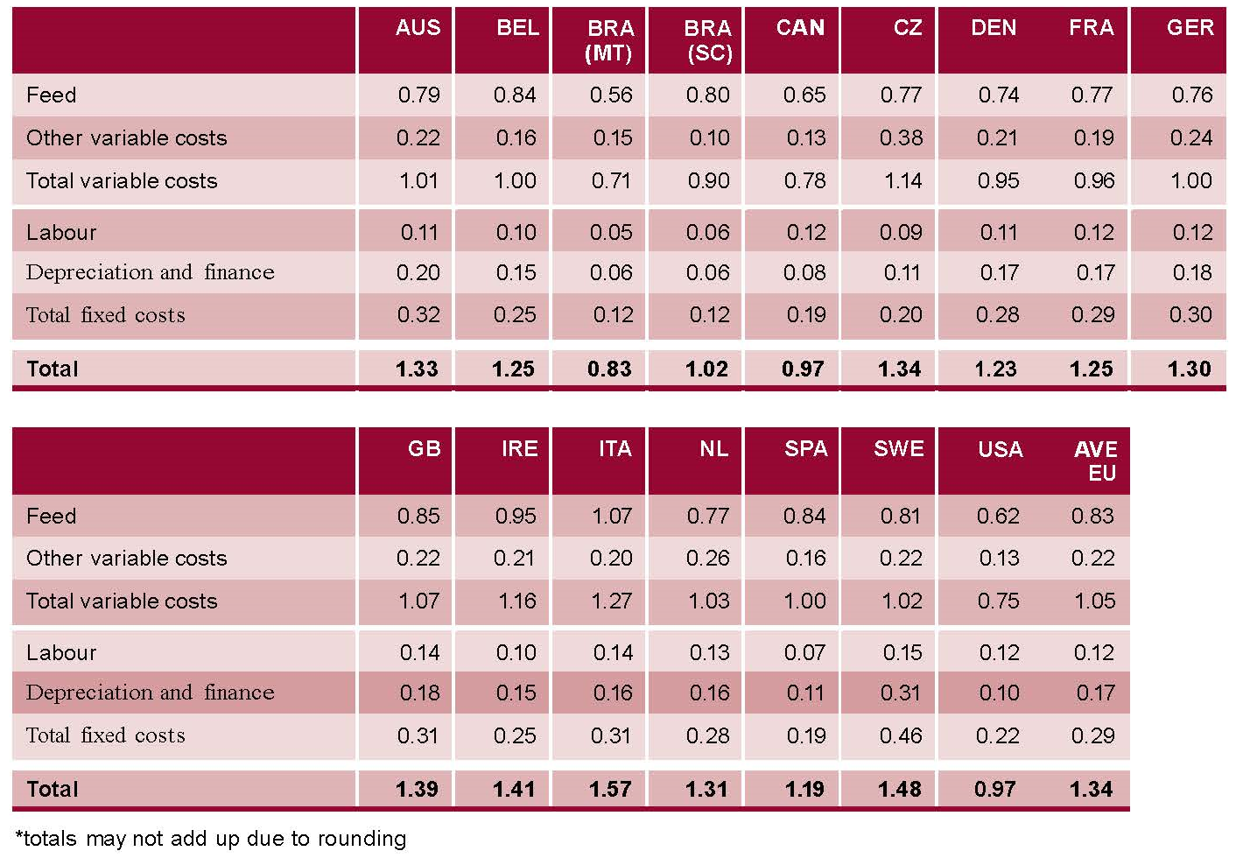
All these are affected by the productivity of each pig farm. The performance parameters that are commonly used to measure the productivity of swine, include the average daily weight gain (A.D.W.G.) and conversion ratio of feed to meat (F.C.R.) (Black et al., 2001).
The data below comes from farms in Greece and Russia, and on them the analysis of production costs will be based on.
Table 3. Piglets up to the age of 35 days
Age in days |  | Age in weeks | Live weight in kgs |  | Average daily weight gain (ADWG) in Kgs | Feed consumption |  | Feed consumption for the whole period | Feed ratio | Weekly weight gain in Kgs | Weight gain for the whole periodin Kgs | Live weight in the end of the period in Kgs
From | To |  | From | To |  | g/ day | Kg / week
0 | 7 | 1 | 1,00 | 1,63 | 0,09 | 0,01 | 0,07 |  |  | 0,63
7 | 14 | 2 | 1,63 | 3,15 | 0,217 | 0,022 | 0,175 |  |  | 1,52 | 6,63
14 | 21 | 3 | 3,15 | 5,18 | 0,29 | 0,035 | 0,245 | 5,04 | Θ1 | 2,03
21 | 28 | 4 | 5,18 | 7,63 | 0,35 | 0,25 | 1,75 |  |  | 2,45
28 | 35 | 5 | 7,63 | 10,08 | 0,35 | 0,4 | 2,8 |  |  | 2,45 | 2,45 | 10,08

Table 3 presents the data concerning the weighing body weight and feed intake for piglets from birth up to the 35th day of age. At this time period the feed that is provided is Θ1 (prestarter). It should be noted that the diet program applied is based on providing three diets from birth to the end of the development stage (35 kg L.W. approx.).

Table 4. Development stage
Age in days |  | Age in weeks | Live weight in kgs |  | Average daily weight gain (ADWG) in Kgs | Feed consumption |  | Feed consumption for the whole period | Feed ratio | Weekly weight gain in Kgs | Weight gain for the whole period in Kgs | Live weight in the end of the period in Kgs
From | To |  | From | To |  | g/ day | Kg / week
35 | 42 | 6 | 10,08 | 12,33 | 0,321 | 0,543 | 3,80 |  | Θ2 | 2,25
42 | 49 | 7 | 12,33 | 14,93 | 0,371 | 0,800 | 5,60 |  | Θ2 | 2,60
49 | 56 | 8 | 14,93 | 18,49 | 0,508 | 0,900 | 6,30 | 42,20 | Θ2 | 3,56 | 21,71
56 | 63 | 9 | 18,49 | 22,69 | 0,600 | 0,500 + 0,500 | 3,50+3,50 |  | Θ2+Θ3 50%+50% | 4,20
63 | 70 | 10 | 22,69 | 27,09 | 0,629 | 1,300 | 9,00 |  | Θ3 | 4,40
70 | 77 | 11 | 27,09 | 31,79 | 0,671 | 1,500 | 10,50 |  | Θ3 | 4,70 |  | 31,79

After ratio Θ1 that mentioned before, Θ2 follows until the 9thweek of piglets age and finally Θ3 until the 12th. This method is known as Phase feeding and was developed because of the drastic changes that occur in the ability of the digestive system and feed intake after weaning. It involves the administration of several rations for a relatively short time, in order to meet more accurately and economically the nutrient requirements of pigs. The prestarter ratio is based on increased participation of high quality and digestibility feeds and granted also for the period after weaning. Then gradually the high quality and expensive feeds are replaced with less expensive and with a lower nutritional value. With this method the nutritional needs of swine are met more effectively and economically.
Table 5. Phase A of Fattening
Age in days |  | Age in weeks | Live weight in kgs |  | Average daily weight gain (ADWG) in Kgs | Feed consumption |  | Feed consumption for the whole period | Είδος τροφής | Εβδομαδιαία αύξηση βάρους Kg | Αύξηση βάρους στο σύνολο της περιόδου | Ζων βάρος στο τέλος της περιόδου
From | To |  | From | To |  | g/ day | Kg / week
77 | 84 | 12 | 31,79 | 36,79 | 0,714 | 1.600 | 11,20 |  | Θ3 | 5,00
84 | 91 | 13 | 36,79 | 42,19 | 0,771 | 1.750 | 12,25 |  | Πρ | 5,40
91 | 98 | 14 | 42,19 | 47,89 | 0,814 | 1.850 | 12,95 | 81,20 | Πρ | 5,70 | 34,00
98 | 105 | 15 | 47,89 | 53,79 | 0,843 | 2.000 | 14,00 |  | Πρ | 5,90
105 | 112 | 16 | 53,79 | 59,79 | 0,857 | 2.100 | 14,70 |  | Πρ | 6,00
112 | 119 | 17 | 59,79 | 65,79 | 0,857 | 2.300 | 16,10 |  | Πρ | 6,00 |  | 65,79

Πίνακας 6. Β’ Φάση Πάχυνσης
Age in days |  | Age in weeks | Live weight in kgs |  | Average daily weight gain (ADWG) in Kgs | Feed consumption |  | Feed consumption for the whole period | Feed ratio | Weekly weight gain in Kgs | Weight gain for the whole period in Kgs | Live weight in the end of the period in Kgs
From | To |  | From | To |  | g/ day | Kg / week
119 | 126 | 18 | 65,79 | 71,79 | 0,857 | 2.400 | 16,8 |  | Π | 6,00
126 | 133 | 19 | 71,79 | 77,84 | 0,864 | 2.500 | 17,5 |  | Π | 6,05
133 | 140 | 20 | 77,84 | 84,09 | 0,893 | 2.800 | 19,6 |  | Π | 6,25
140 | 147 | 21 | 84,09 | 90,59 | 0,929 | 3.000 | 21,0 |  | Π | 6,50 | 59,10
147 | 154 | 22 | 90,59 | 97,39 | 0,971 | 3.100 | 21,7 |  | Π | 6,80
154 | 161 | 23 | 97,39 | 104,39 | 1,000 | 3.300 | 23,1 |  | Π | 7,00
161 | 168 | 24 | 104,39 | 111,39 | 1,000 | 3.300 | 23,1 |  | Π | 7,00
168 | 175 | 25 | 111,39 | 118,39 | 1,000 | 3.300 | 21,7 |  | Π | 7,00
175 | 182 | 26 | 118,39 | 124,89 | 0,929 | 3.000 | 21,0 | 185,50 | Π | 6,50 |  | 124,89

Tables 4, 5 and 6, present the same information for the rest of the growing season and the A and B phase of fattening, respectively.

Table 7. Breakdown of sows feed consumption
Farrowings per year | Lactation length in days | Average feed intake per sow per day | Days inlactation per year | Total lactation feed intake per sow per year | Days in gestation and dry period per year | Average gestation feed intake per sow per day |  |  | Total gestation feed intake per sow per year
2,3 | 28 | 6,5 | 64,4 | 422,5 | 300 | 2,7 |  |  | 810
Total feed intake per sow per year = 1232,5kg

Surcharge on F.C.R. (22 pigs to slaughter) = 56 Kg

Total feed consumption per fattener = 313,94 Kg
(Tables 3,4,5,6)
Total feed consumption per fattener including sow feed= 369,94 Kg
Table 7 shows the feed consumption per sow per year and the sharing of that feed per fattening pig. Finally, Table 8 shows the feed conversion ratio for each stage stated and in total for the whole period.
Table 8. F.C.R.
F.C.R.Nursing piglets | 0,555
F.C.R.Growing piglets | 1,94
F.C.R.Α’phase of fattening | 2,39
F.C.R.Β’phase of fattening | 3,14
F.C.R. totalperiod | 2,53
F.C.R.including sow feed | 2,986

Given that the measured F.C.R. in the farm level is 3: 1 and the average feed cost, for the Greek case, was about 0,28 €/Kg in 2015, it seems that the feed cost per kilogram live weight produced is 0,84 €. Compared with the data in Table 2, which refer to feed cost per kilogram carcass (in pounds sterling, with current rate of 1 € = 0,84 £), becomes obvious the non-competitiveness of pig farming in Greece, due to the high feeding cost. Compared to the average costs at European level (carcasses yield 79% x 0,98 € = 0,77 € / kg L.W.) it seems that the feed cost to produce a kilo of live weight pig in Greece is by 9% higher to the European production cost.

Assessment of green energy production per kilogram of pork live weight.
Valuation unit: kw per 1000 kg of live weight.
As mentioned above, the feeding cost represents 65% of production costs. The main difference between Greece and other European countries, especially the neighboring Balkan countries, concerns the prices of grains, which are on average about 8 cents higher per kilo or 80 € per tonne. This is confirmed by the fact that the transport of cereals from the Balkan countries burdened with an average cost of transport of 5-8 cents, depending on the geographical region of Greece.
In this way, the mean burden in pig meat production is 3 (F.C.R. from Table 8) multiplied by 8 cents ie 0.24 € per kilogram of meat L.W. produced (involves Central and Southern Greece) while in Northern Greece, because of the proximity to the Balkan countries, the amount is about 0.17 €. Balancing the increased production costs through the profit from the production of green energy in the above amounts, the following are obtained:
Α) The pig farmer can buy the more expensive Greek cereals in the price derived from the cost of imported cereals plus transportation cost, ensuring high prices of cereals for the Greek farmers.
Β) Ensures that the cost of production is the same as that of the Northern European countries.
Γ) Pig meat production becomes profitable in Greece which, in second phase, can evolve to an exporting country.
Δ) It gives jobs to the Greek economy by activating a set of collateral crafts and industries currently underperforming (slaughterhouses, meat processing plants, crafts and industries of livestock machinery & equipment, construction industry, etc.).
Ε) For all the above, supporting the production activities, guidelines must exist, so that producers, do not get involved in a wrong investment from the beginning, as they lack the necessary expertise.
F) There must be a connection between the production of animal products (meat, milk, etc.) with compensation.
Based on the above, the following options arising for connecting RES with pig meat production:
1) If the price of 1 Kwh is 0.28 €, then 1,000 Kwh are required to balance the feeding cost of 1tonne of pig L.W. Additionally, 200 Kwh of energy are required for the farm’s own consumption, or a total of 1,200 Kwh.
This approximately corresponds to a photovoltaic park of 1000 KW production capacity for a 500 sow unit, or calculating on the basis of sow 2 kW per head are required.
2a) A unit or an aggregate of neighboring units of 2000 sows, can support with its wastes a biogas plant with500 KW production capacity, or about 4.200.000 Kwh / year. The creation of producer groups should be investigated (pig, cattle, poultry, sheep and goat farmers) to establish joint ventures, which will produce electricity and provide thermal energy.
2b) The emitted thermal energy, corresponding to 60% of the energy produced, can be given to heating either greenhouses or dryers according to local needs.
3) Composting of wastes for the production of organic fertilizers - soil enhancers.

REFERENCES
AHDB Pork. 2014 pig cost of production in selected countries. ISBN: 978-1-904437-96-3
Black JL, Giles LR, Wynn, PC, Knowles AG, Kerr CA, Jones MR, Strom AD, Gallagher NL, Eamens GJ. Factors limiting the performance of growing pigs in commercial environments, in: Proceedings of the Eighth Biennial Conference of the Australasian Pig Science Association (APSA), November, 2001, Adelaide Werribee, Victoria, pp. 150–170.
In K. Han, J. H. Lee, J. H. Kim, Y. G. Kim, J. D. Kim & I. K. Paik (2000). Application of Phase Feeding in Swine Production, Journal of Applied Animal Research, 17:1, 27-56, DOI: 10.1080/09712119.2000.9706290
Interpig report 2014. http://www.sipconsultors.com/en/home.
Kitsopanidis, G., (1980), Economics and Productivity of the Pig Industry-TechnicoeconomicalAnalysis, Thessaloniki, Laboratoryof Agricultural Economic Research, AUTH
Kitsopanidis, G., (1999), Sustainability and competitiveness of modern pig farms.AnimalScienceReview, Issue 2, p.33-51.
Batzios, Ch., (2001), Animal Production Economics, Thessaloniki. Publisher: Modern Education.

