ANTIBIOTICS IN ANIMAL PRODUCTION: PROBLEMS AND ALTERNATIVES
A.N. Panin
Academician of the Russian Academy of Sciences
Member of the French Academy of Veterinary Medicine
Member of the working group on the safety of livestock products of the World Organization for Animal Health (OIE)
INTRODUCTION
The World population throughout the centuries is increasing rapidly.
More specifically, while in 1500 the world population was 500 million people, in 1800 reached 1 billion, in 1900 1.65 billion while in 2013 seven billion people are living on the planet.
chronology | world population
1500 | 500.000.000
1800 | 1.000.000.000
1900 | 1.650.000.000
2013 | 7.000.000.000

The trend of increasing world population in combination with medical recommendations for human nutrition, leads to a projection for an increased consumption of animal protein by humans of about 50% by 2020.
This increase will bring to scientists around the world, a number of challenges. One of these is the improvement and development of new tools for the prevention and treatment of animal diseases, with the aim of increasing production.
USE OF ANTIBIOTICS IN LIVESTOCK PRODUCTION.
Antibiotics in livestock production are used for:
- Treatment against diseases
- Prevention of the occurrence of diseases
- Metaphylaxis i.e. for treating and preventing the recurrence of diseases
- Improving the development and acceleration of building of muscles
It is true that in recent years in almost all countries of the world, there is excessive use of antibiotics. Farmers feed farm animals with million kilograms of antibiotics as growth promoters.
This results in the rapid development of resistance to antibiotics not only from pathogenic organisms, but also to the change of endogenous microflora of the digestive system which is transferred from generation to generation for thousands of years.
The global scientific community is on alert. The era of antibiotics is ending. Of course due to them, to a great extent, the world's population in the 20th century quickly reached 7 billion inhabitants.
The victorious attack against bacteria is over.
Among the bacteria, resistant strains have already appeared that do not respond to any antibiotic.
Antibiotics are substances produced by yeast, fungi, algae and bacteria to protect them and to destroy their rivals in the struggle for nutrients. The mechanism of resistance to antibiotics has developed during the 3.5 billion years of existence and evolution of bacteria. Thus, antimicrobial resistance is a derivative of the natural environment of the planet.
This is the first direct demonstration that antibiotic resistance is a widespread natural phenomenon that existed before the modern use of antibiotics. The fact that the resistance genes are both ancient and widespread, means that there are no easy solutions to the problem of resistance and probably a ledger antibiotic will never be found or created.
The Universal Conference of the World Organisation for Animal Health held in 2013 in Paris, had as main theme the wise and responsible use of antibiotics. At the conference, consensus was reached on the need for an international cooperation and solidarity for the assurance of supervision of the imports, marketing, distribution and use of antibiotics.
In the decisions that were taken, it was agreed that, at a global level, a more restrictive legislation on good practice in production management, imports, registration, marketing, distribution and use of veterinary quality drugs should be taken and also to ban the use of certain antibiotics.
Other important conclusions of the Conference were:
- Antibiotics are not simple products and the sale as well as their use cannot be free. There is not a total optimum antibiotic delivery system to the farms.
- The optimum way for the delivery of antibiotics to farms and their use for the treatment of animals is via a veterinary network where specialists’ veterinarians with special training `are working.
- The veterinary practice, as well as the medical and pharmaceutical ones, will be conducted in accordance with the laws which guarantee the ethics and exclude the use of self-interest for the prescribing and use of antibiotics.
This is one of the most important points in the practice of good administration as declared by the World Organisation for Animal Health (OIE) and provide a basis for the implementation of OIE programs. ΟΙΕ fully supports the concept of "Unified health" that include the triangle animal - man - environment.
Over 60% of infectious diseases of animals and humans caused by the same pathogens, which requires that priority should be given to strengthen and improve the coordination of activities for the protection of animal and human health, taking into account the impact of environmental factors.
In this context, the World Organisation for Animal Health has proceeded in the following actions:
- The requirements for the rules of good management by the Veterinary Services have been improved for a better control of the registration, importation, distribution and use of antibiotics in farms.
- The information and monitoring system of the antibiotics used in animal husbandry have been improved.
- The harmonization of national monitoring and surveillance programs for antibiotic resistance of pathogenic and toxigenic microorganisms, especially salmonella, is in development, and the international coordination and improve of national programs is completed.
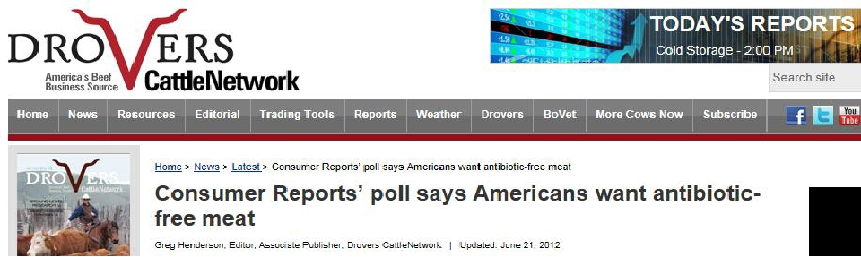
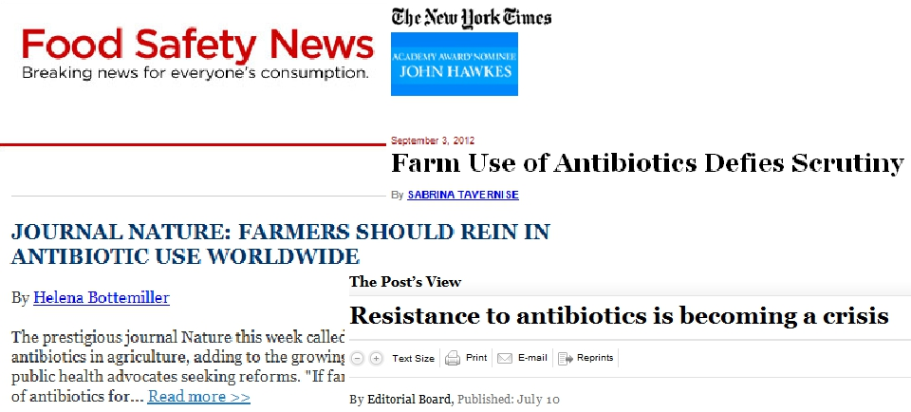

For antibiotic-resistant bacteria there are no borders. Mismanagement of antibiotics in one country may endanger many other. The members of the World Conference on antibiotics supported the strengthening of cooperation to help the countries which are still not using the OIE standards on antibiotics.
The growing lack of sensitivity for antibiotic, of the pathogens that cause dangerous human diseases (over 60% of these are common diseases in humans and animals) equalized from the chief doctor of Britain, Sally Davies, with a terrorist threat. Up to three thousand patients die each year in the UK due to the ineffectiveness of antibiotics because the pathogens of infectious diseases are resistant to them.
The development of new generation antibiotics deemed unprofitable worldwide. A typical example is that since 1987 not any new antibiotic has been developed.

ALTERNATIVE TO ANTIBIOTICS
There are actions that can be made which offer an alternative to antibiotics. These are:
- Ensuring animal welfare
- Vaccines
- Probiotics
- Prebiotics
- Herbal preparations - Phytomedication
- Essential oils
- Heavy metals
- Small interfering RNA (siRNA)
- Recombinant and medical hyperimmune sera
- Organic acids
- Bacteriophages
- Genetic products by bacteriophages
- Antibacterial products of animal origin
- Naturally antibacterial lytic enzymes
- Immunostimulants

Antimicrobial peptides OF ANIMAL ORIGIN
The antimicrobial peptides of animal origin are present in all organisms.
The oldest of these are:
- Cathelicidin (snakes)
- Plastrin (grogs)
- Cecropin (insects)
- Bacteriocin (bacteria)
These peptides are characterized by their rapid onset of their action after the introduction and have a broad spectrum of activity, they are at the forefront of the fight against infections.
They kill bacteria destroying their membranes, while some peptides destroy the intracellular structures and have cytotoxic activity.
The American Chemist Society, based on a study of 600 species of frogs found that the skin of frogs may be a source of strong antibiotics. The scientists were able to identify more than one hundred compounds with antibacterial properties on the skin of different species of frogs. Thus the skin of frogs, who are on Earth for about 300 million years is a possible source of antibacterial agents.

ALTERNATIVE SUBSTANCES IN ANTIBIOTICS
Considered as drugs or biological products, or feed additives,
They must be produced in accordance with national and international standards, by firms which are licensed to produce them under the supervision of the authorized services,
They must comply with established standards for safety, quality and efficacy.

PERSPECTIVES
The integration of scientific research in the field of Nutritional Science, Health and the study of diseases resulting from the technological progress and the use of «omics*» – technologies in animal husbandry.
* « Omics» – the common name of a number of biological disciplines of science: genomics, proteomics, metabolomics, etc.
These technological developments will include new research methods, which will give scientists the not available before ability to identify the mechanisms by which it is possible to use alternative means to improve health, productivity and welfare of animals.
There is an urgent need for the development of new antimicrobials and of alternative means for the prevention and treatment of infectious diseases, to limit the application of antibiotics used now, but we must take into account the problem of resistance.
A cooperation between the scientific and government experts should be established, between the feed and pharmaceutical industry and the relevant regulatory authorities, to ensure the development of effective and safe alternatives.
Understanding the mechanism of the development of resistance to antibiotics will continue to be a major issue.
However, it is necessary to have the support of all parties concerned, corporates and public and governmental organizations, in the field of solving both the problem of the development of solutions with a reduced risk of microbial resistance, and the development of alternative approaches for improving the health and welfare of animals.

