The health of the intestinal epithelium as an important factor of pig’s health and the new technologies for its management
After 60 years of continuous use of antibiotics in pig farming, the resistance of bacteria is an issue that cannot be ignored. The way antibiotics work in relation to the improvement of pigs zootechnical parameters (average daily gain, feed conversion ratio) is not totally known. Nevertheless, the fact that we are familiar with the intestinal bacterial flora and bacteria communities, as well as with the influence of antibiotics on them, could provide us knowledge about the use of alternative approaches regarding intestinal health. Many studies have shown modifications in bacterial populations after the use of antibiotics in the feed, which includes number of species, populations’ size and functional defects. Moreover, the genes resistant to antibiotics increased in intestinal bacterial population after they were exposed to feed antibiotics.
The eventual transport of resistance genes from animal bacterial populations to similar or different bacterial populations in human, leads almost all countries of the world to the development of research, in order to find alternative approaches, especially for non therapeutic use of antibiotics in the feed, that is prohibited in the EU countries since from 2006.
Although the use of antibiotics in the feed resulted in an improvement on performance of more than 20% in comparison to the genetic improvement (50% from 1970-2015), made scientists and producers to neglect other factors, such as qualitative nutrition, optimum zootechnical management and pigs’ welfare and finally farm environment.
The actual belief about the use of antibiotics in the feed of pigs is that the antibiotics have an impact in the total bacterial flora and on the microbiota. However, until recently, their influence on the microbiota was not easy to measure, because pig’s intestinal system houses a variety of micro-organisms that are under specific environmental and nutritional conditions. It is well known that the number of bacterial populations in the body of a pig, exceed the amount of 10¹³, while the normal cells reach the amount of 10¹². The same stands for the bacterial genes that exceed the cellular genes by 100 times.
Bacterial resistance:
1993: First veterinary fluoroquinolone
1995: Enterococci resistant to vancomycin
1996: Resistance of B. Hyo to tiamulin
1996: Mutli –resistance to tuberculosis
1997: Resistance of Str. Pneumoniae to penicillin
1997: Third generation of cephalosporin to animals, celtiofur
1999: Second pleuromutilin to the animals, valnemulin
2003: New generation of antibiotics ( lipopeptides), Daptomycin
2006: MRSA in pigs
2007: First human pleuromutilin, Ratapamulin
2012: New microlide for pigs, tildipirosin
2015: First case of multi-resistance in human
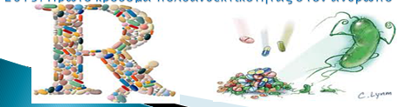

Brief history of antibiotics use in pigs

Additionally, the interactions between the microbiota and the host, have extremely positive effects to the animal’s health, protect its metabolism function by supporting the extraction of the nutrients from the feed, develop the animal’s immune system so to face eventual microbial dangers, develop the intestinal epithelium and consists a normal defense mechanism against pathogens. The production of microbial degradation products in the gastrointestinal track, provides pigs with nutritional ingredients and energy, such as vitamins, volatile fatty acids, growth factors and promotes symbiotic bacteria. Experiments conducted to germ-free pigs, have shown that the expression of the animal‘s genes is affected, especially of those related to the maturation of the intestinal mucosa, the absorption of nutritional elements and angiogenesis, while they require 30% more calories compared to conventional pigs so they can maintain their body weight, mainly because the germ-free pigs do not have bacterial groups that can help in the extraction of the feed nutrients in the digestive track.
The interaction of bacterial populations and intestinal mucosa is mostly beneficial except for few cases, as in humans (Crohn disease and ulcerative colitis), while changes in the bacterial populations end up to the irritable bowel syndrome.

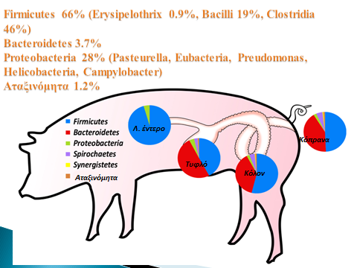
Variability of bacteria populations in the digestive system of pigs

The intestinal mucosa is made of various and different specialized cells. The enterocytes are absorbent cells, are in the villi and they have micro villi themselves, to increase the surface of the digestion. Paneth cells are found deep in the crypts and they excrete the main antibacterial peptides produced in the small intestine. These peptides are excreted only in presence of bacteria flora and include alpha-defensin, lysozyme and the regulatory factor Illy. Moreover, bacteria that live in the mucosa, maintain the O2 in a level that is not favorable for the growth mainly of the obligatory anaerobic pathogens, while the columnar epithelial cells (goblet cells) create a thick layer of mucosa that prevents the contact and penetration of pathogens in the intestinal mucosa. Additionally, the immune system is very important for the maintenance of balance between the host and the microbiome. The Payer plates and the cylinder lymphatic follicles are covered by specialized epithelial cells called M-cells that “catch” first the antigens directly from the intestinal track and they present them to T-lymphocytes, helping the immediate production of B cells (antibodies) and memory cells. Without the presence of bacteria populations, the lymphocytes cannot grow and the B cells cannot mature from Τ cells through factor Th 17, nor can its production be controlled through regulatory T cells. As a result, each pig is vulnerable to any disease.
Consequently, without the special metabolic functions of bacteria and the final products of fermentation, pigs cannot be healthy nor optimize their performance by taking full advantage of their genetic material.
The epithelium of the large intestine depends exclusively from the nutritional products of the fermentation process effected by the bacteria existing in it and producing energy.
Therefore, the question is how the metabolic functions of pigs’ digestive system can be maintained with the maximum presence of beneficial bacteria, but without the use of antibiotics in the animal feed, given that their presence in the ratio has a negative influence on the intestine bacterial flora. At the same time, public opinion, consumers express their strong concern about the increasing microbe-resistance that becomes even multi-resistance, by pushing their governments to study carefully the issue of health management, especially for swine and birds, since there is a big number of resistance genes which is detected in the το microbiome of monogastric animals. Even if antibiotics are not used, in case of organic farming, a big number of resistance genes is detected in tetracyclines encoding plasmids. When the resistance is in the plasmids, then it spreads rapidly, even between bacteria and pathogens that are not related, while other scientific researches show that only the presence of antibiotics in the feed facilitates the transport of resistant genes via the lysis of bacteriophages.
Staphylococcus aureus resistant to Methicillin, has been detected in pigs in the 70’s. Today it is not considered as an animal pathogen, but it is a significant problem for human’s health.
Are there alternative solutions for minimizing the use of antibiotics in pigs feed, without put in danger the digestive system health? It is obvious that lesser diseases mean lesser use of antibiotics. However, the question does not concern the use of antibiotics in sick but in healthy animals. Are there viable solutions for the zootechnical performance to be kept and even improved, without the use of antibiotics in feed, something that is happening already in the EU, but by having a control over the level of the animal’s infection?
The characteristics of this system must definitely include changes in the animals’ nutrition, the micro-environment of the livestock farm, the bio safety systems and the preventive health management via vaccinations and then a system of specific interventions by using active substances/additives, that affect positively the digestive system and the metabolism of the animal and bring significant improvement to swine health.

Technologies based on holistic management of pig’s health without the use of antibiotics
Energy and protein sources | Alternative supplements | Standard Health Management
Blood plasma | Hyperimmune eggs | Biofilters
Milk protein | Oligosaccharides | Biosafety
Conventional egg products | Probiotics | Vaccination program
Lactose | Prebiotics | Disinfection
 | Phytogenics / essential oils | Farm microenvironment
 | Organic acids | Resistant breeds in specific diseases
 | Dietary fibers | Model farms with automated measuring systems
 | Yeast, yeast products
 | Bacteriocins
 | Enzymes
 | Clay minerals
 | Butyric acid
 | Middle / Short chain fatty acids

It is well known that the genetic potential of the pig allows today to reach 10 Kg L.W. in 28 days, 45 Kg in 75 days and 100 Kg in 130 days, if fed solely on milk products. The use of porcine plasma products (spray - dried plasma) has proven to improve growth rate by 30%, and possibly due to the immunoglobulins contained in plasma provides protection against intestinal and other diseases. Alternatively, the use of hyperimmune eggs, from hens immunized for specific pig pathogens and produce antibodies against them, constitutes a contemporary way to address the absence of antibiotics in feed and their nutritional use brings passive immunity against specific diseases. It is a fact that the expression of clinical disease is dramatically reduced and yields are greatly increased with the use of dehydrated porcine plasma or hyperimmune eggs. The use of lactose, which is an easily digestive carbohydrate is a key factor for the feeding of pigs, but can also act as a prebiotic, i.e. a nutrient medium for the growth of beneficial bacteria, while stimulates the production of lactobacilli in the stomach resulting in the production of lactic acid that simulates the action of the incorporation of an organic acid in the feed.

Health of the gut: Back to basics
Nutrition
Development : 30th day 15kg, ADG 600g
30th day 10kg, ADG 400g
50th day 32kg, ADG 700g
50th day 19kg ADG 500g

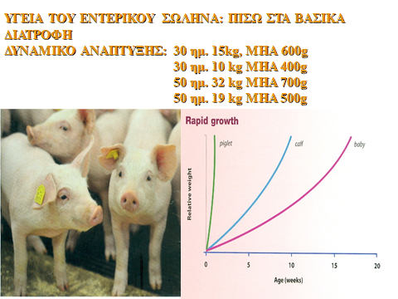
Potential of pig growth

Regarding alternative supplements, mannose and fructose oligosaccharides predominate, constituting complex compounds of the outer layer of the cell wall of yeast. It is considered that they a competitive act on the receptors binding pathogenic bacteria, in order not to adhere to the intestinal mucosa. Technologies where prebiotic must survive the digestive process are important to let it act effectively.
Probiotics and prebiotics. Probiotics are vital or sporogenous bacteria added to pig feed as an alternative strategy to strengthen the microbial flora of the gut. Food production in the form of pellets (pellets) reduces the effectiveness of their use, especially for lactobacilli or bifidobacteria species, but microencapsulation techniques may make them more resistant. In any case, the strains used should be acid-fast. Alternatively, instead of adding in the feed beneficial bacteria, we can use substrates for the growth of beneficial bacteria and we come back to the use of prebiotics which are again mannan-oligosaccharides, trans galacto-oligosaccharides and fructo-oligosaccharides. These are the end products of non-digestible fermented sugars which favor the development of lactobacilli, but in feed, besides the final products mentioned before, raw materials can be used such as, sugar beet, apple and horseradish pulp. that contain also large quantities of inulin - dietary fibers.

Technologies for the protection of the organic acids and essential oils and ideal release in the digestive system

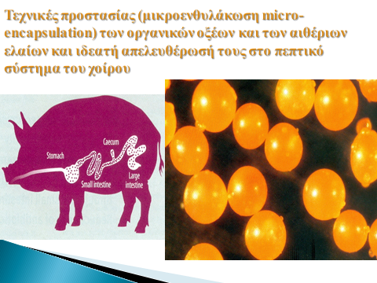

Dietary fibers consist mainly of non-starch polysaccharides, i.e. carbohydrates which are not digested by the digestive enzymes of the pig. Thus, because they avoid digestion in the small intestine, remain available for microbial fermentation in the colon, resulting in energy production while supporting and maintaining the fermentative bacteria. They stimulate the secretion of hydrochloric acid in the stomach, creating a highly acidic environment that prevents the growth of pathogenic bacteria. Their administration is not recommended in nursing piglets, as they are already receiving lactose resulting in the production of lactic acid which stimulates the action of hydrochloric acid. Inulin and oligofructose stimulate the growth of bifidobacteria and lactobacilli resulting in the production of volatile fatty acids which contribute to the barrier of pH acidity. Volatile fatty acids such as acetic and propionic acid are active against pathogens. Also, butyric acid plays a key role in the regeneration of damaged epithelial tissue, a known problem of weaned piglets mainly due to the changes in the composition of feed, bacterial toxins and feed allergies.
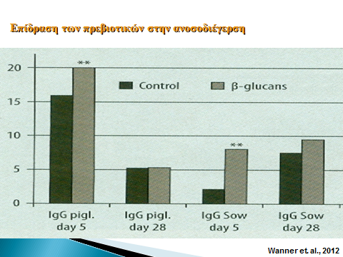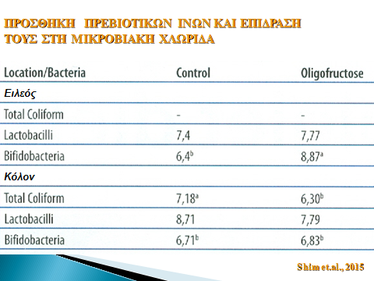
INFLUENCE OF PREBIOTICS IN IMMUNOSTIMULATION/ boutyric acid in e digestive system

At the same time, they increase calcium absorption, regulate gut motility and reduce the emission of ammonia, as the reduction in pH alter the microbial metabolism from proteins, to carbohydrates, creating a better microenvironment for sustainable pig production systems.
Short chain fatty acids produced spontaneously by the pig when dietary fiber and non-digestive forms of sugars are fermented in the large intestine by the microbiome. The most frequent and important fatty acid is butyrate as it is the preferred metabolite of colonocytes. The absorption mechanism by the epithelial cells of bacteria creates a source of ATP which delivers energy activating the sodium pump maintaining osmotic balance in the intestine allowing water to be reabsorbed in the large intestine and the relatively watery wastes to become more solid faeces. The mechanism is based on consumption of Ο₂ and the lack of it is making the lining of the colon hypoxic, resulting in anaerobic conditions that favor the growth of clostridia necessary for the production of endogenous butyric acid. In other words, a self-supply mechanism is created in the large intestine.

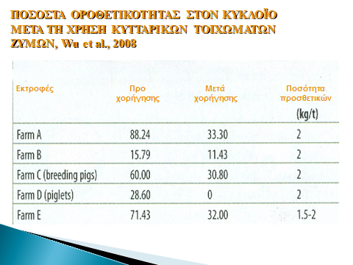
Percentage of positive infected in circovirus after the use of yeast cell walls.

The gut is the largest immunologically active organ. Short-chain fatty acids have an important role in homeostasis of the gut, but act also as a vital link between the porcine microbiome and the host’s immunity. They affect the gene expression, proliferation and apoptosis of the intestinal epithelial cells. Butyrate increases the proliferation of enterocytes in the crypts, while increasing apoptosis of epithelial surface cells balancing cellular changes in the gut level. Mobilizes antimicrobial peptides, neutrophils, while regulating the presence of dendritic cells and macrophages mainly present by bacterial antigens to T lymphocytes. Protected forms of butyric acid gives the possibility to overcome the problem of gastric acidity, while esterified forms such as tributyrin have shown to be more active.

MCFA – MODE OF ACTIONS

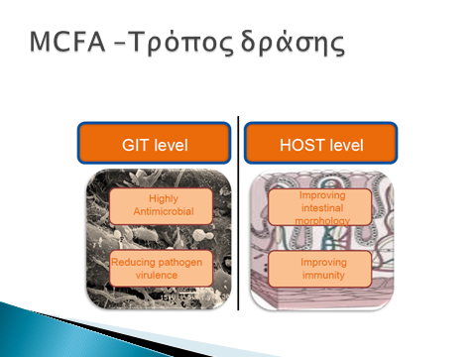

As the butyric acid found in the milk of the sow in a complex form with a glucose molecule, so do the new forms of administration that have strong ties respective to triglycerol which are degraded only by enzymes, such as lipase. Thus the form of tributyrin crosses the barrier of the stomach and under the influence of pancreatic lipase release butyric acid in the intestine yielding 200% more acid than the protected forms of the salts.
In addition to the short chain fatty acids, medium chain fatty acids exhibit beneficial effects on pig health and performance. The A-monolaurin is a molecule produced by the esterification of lauric acid and glycerol, detached of the pH action, absorbed by the lymph and the circulatory system. The strong antibacterial property, particularly on Gram + bacteria, is known in the literature, especially against Streptococci and with antiviral properties especially against arteriviruses (PRRS). Monoglycerides exhibit very strong antibacterial properties against free fatty acids and their use constitutes an alternative agent for production of the new generation models with antiviral and antibacterial activities promoting animal health and their performance in the absence of the use of chemotherapeutic.
The benefits from photogenic feed additives have been extensively described in the literature, however is a fact that many of the properties of the essential oils, while they have been extensively studied in vitro they have not been identified completely in vivo, but their activity also shows large variations depending on the secondary metabolites of the plant species with those depending on the botanical composition of the plant from which the additive has come.
The photogenic supplements are herbal ingredients such as herbs, essential oils or aromatic plants and are used for many years for medical reasons.
The photogenic components can be extracted from different plant parts and composed of almost all organs of the plant (stems, roots, flowers, bulbs, nuts).
Essential oils are a small part of the plant composition. They have however certain characteristics which are used in the food industry and pharmacology. Their action as additives in animal nutrition appears as anti-inflammatory, buffering the microbiome of the bowel, stimulation of the digestion and the action of bile and digestive enzymes, increase of amino acid uptake, having antidiarrheal activity, facilitating the attraction of feed for pigs due to their aromatic properties, improve animal technical indicators even the composition of the carcass (increased percentage of meat).
The main essential oils used in animal production derived from rosemary, thyme, oregano, sage, pepper, bay leaf, and garlic, wherein the respective essential oils exhibit bacteriostatic or bactericidal effect on specific microbes, mainly E. coli, Salmonella spp, Staphylococcus spp, Listeria spp and Campylobacter spp.

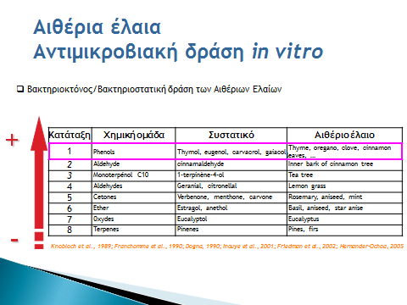
Essential Oils
Antibacterial action in vitro

Finally, a new category for pig nutrition which combines mainly, essential oils -that can affect the bacterial cell, organic acids that can penetrate in the bacterium and affect its functions, and a mixture of fatty acids of small and medium chain that have also antibacterial properties, can lead in a more balanced microbiome, emulating in a degree the mode of action of an antibiotic. The presence of enzymes and probiotics is another way of synergy for the upkeep of the integrity of the mucosa and its effectiveness in zootechnical - production parameters.
Enzymes are widely used in pig nutrition mostly for the disintegration of anti-nutritional factors that hail from raw materials of the ratio (non-starch polysaccharides in cereals) and to decrease the undigested percentage of proteins, fat and carbohydrates, which can be the perfect medium for the growth of bacterial population. Although, the use of proteolytic enzymes is an expensive solution for the improvement of proteins digestibility, their usage is decreasing the viscosity of the intestinal track and prevent the reproduction of pathogen bacteria because of the good mobility of the feed inside the intestinal track.
Also the use of clay minerals such as kaolinite, montmorillonite and attapulgite, alongside with essential oils and seaweed extracts, increase the activity of the peptic enzymes (higher pancreatic lipase and protease), while they have antidiarrheal properties and adsorptive act against toxins especially of mycotoxins.

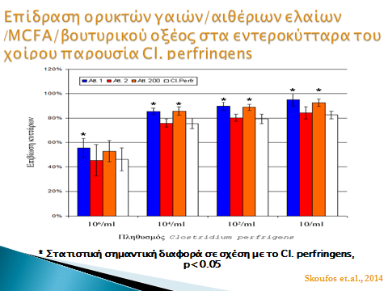
Effect of mineral clay/ essential oils / MCFA/ boutyric acid in enterocytes of the pig with the presence of CI. perfringens

It is also known, that we can use nutritional supplements in alternative ways to affect the microflora of the stomach, of the small and the large intestine. This can be achieved with the strategic grant of medium chain fatty acids for the stomach and the small intestine, small chain fatty acids for stomach and the oral cavity, organic acids for the oral cavity for the stomach and the small intestine, enzymes for the stomach and the small intestine and a mixture of essential oils and phytogenic ingredients for the small and the large intestine.
Their action in synergy can contribute in their absorption from the cellular membrane of pathogenic bacteria which results in the increase of its penetrability in order that their content leak to the extracellular fluid (ECF). On the contrary, organic acids or other phytogenic components can infiltrate in the bacillary cell and intervene in its operations.
Mixtures of additives based on essential oils, prebiotics, and fatty acids can demonstrate antibacterial action not only for gram negative, but also for gram positive bacteria.

SYNERGETIC ACTION

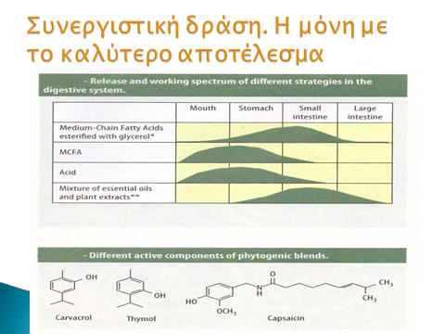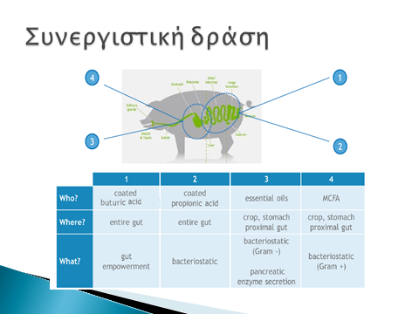

The advantages of micro-encapsulation of organic acids, fatty acids and phoytobiotics, are exceptional, since it prevents the effect of unfavorable environmental factors in their formation (mainly in acidity), increases their bioavailability and their activity along the digestive system, improve their absorption and their stability and demonstrates their advantages. At the same time can partly cover their unpleasant or intense smell that are repellent for the animals.
The digestive system is the key implement for the health both of the men and the animals. It is so important that it is also called “the second brain”. To raise pigs can be compared to an airplane flight. It is very safe but a human mistake can lead to total devastation.
The intestinal track and its complementary organs include more cells than the rest organs of the pig. Furthermore, they direct the metabolism and the immunological maturing of the animal.
Today it is widely known that the health of the pig depends on three basic components of the nutrition triangle: The diet, the intestinal mucosa and the microbiome. The kinds of microbes that can be found in the intestinal mucosa are only known in a percentage of 10% since only the lactobacillus and the bifdobacteria can be cultivated.
The pig nutrition is a modern miracle and can guide the peoples’ nutrition. Diarrheic syndromes, constipation, tolerance in lactose, ulcerous colitis, diabetes etc. The usage of probiotics and prebiotics is the number one issue for human nutrition. The fermented foods, polyunsaturated fatty acids, chelated trace elements, microbiome, wherein particularly the use of enzymes increases eubacterial populations (E. hallii and E. limosum) stimulating the immune system and reducing the number of clostridia in the small intestine.
Many questions remain unanswered. Will the antibiotics be used in the future? How the new technologies (nutrigenomics, omics, transcriptomics, genomics) will guide us to the future strategies of pig health management?
Which is the perfect microbiome for the pig? Does it depend on the breed? Will be resilient breeds at viral and bacterial diseases? Is there a limit in the development of the pig and its reproductive ability?
In the year 2025 a sow will produce 5TN of meat? How this will affect the health of the animal? Where the animal origin proteins will be found? And how will be replaced in the ratios?
The overall approach is not simple. Furthermore, there is not one universal management strategy. Every farm is an individual organization. A combination of practices can offer better alternatives for every individual system and can lead the massive production of pork meat in more specialized models.
In these models, the alternative forms of administration of nutritional supplements which assist the pig health and prevent the widespread use of antibiotics will proliferate defining also consumers’ behavior to techniques and technologies evolving, at least in developed countries.
Let us not forget. Pork is the other white meat after chicken and is the beloved meat of consumers. The new technologies for the health management of the intestinal epithelium are exactly facing the visibility and safety of pork and pork end products.

Application of alternative nutrition supplements in pigs ratio to replace antibiotics
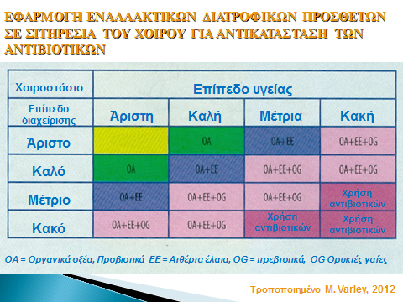

Ioannis A. Skoufos, Professor, D.V.M., M.Sc., Ph.D.
Laboratory of Animal Health and Swine Production
Dean of the School of Agriculture Technology, Food Technology and Nutrition
Division of Animal Production
Technological Educational Institution (T.E.I.) of Epirus
Kostakioi, Arta, 47100, Greece,
Tel. 30-26810-50204
Fax. 30-26810-50527
Μοb. ++306944364798
email. jskoufos@teiep.gr

